00000000000000000000000000000000000000000000000000000000000000000000000000000000000000000000000000000000000000000000000000

JC Rupe

Date: **June 12, 2017**

Version: **1.0.0**



**Project JIM:**

*Reactivate a Move – Quick Ref*

**IT Project Management Office**

Document Revisions

|  |  |  |
| --- | --- | --- |
| Date | Version Number | Document Changes |
| 2017/06/12 | 1.0.0 JC | Create quick reference guide |
|  |  |  |
|  |  |  |
|  |  |  |
|  |  |  |
|  |  |  |
|  |  |  |
|  |  |  |
|  |  |  |

Contents

1 Reactivate Move Quick Reference Guide 3

1.1 Locate the Move to be reactivated 3

1.1.1 Move number is known 3

1.1.2 Move number is unknown 3

1.2 Activate the Move 4

1.3 Reopen a Service Activity 4

# Reactivate Move Quick Reference Guide

This document is a quick reference guide to reactivating a Move and its associated Service Activities. When a Move is deactivated all the associated active Service Activities are automatically canceled. After reactivating a Move, each of the Service Activities must be individually reopened.

## Locate the Move to be reactivated

1. Navigate to JIM.
2. If you know the Move number, perform the steps in section Move number is known.
3. If you don’t know the Move number, perform the steps in section Move number is unknown.

### Move number is known

1. Navigate to the **Moves** view page.
2. Select the System View for I**nactive Moves**.
3. Filter for the desired Inactive Move.
   1. Turn filtering on.
   2. On the Name column, perform a “Custom Filter…”.
   3. Filter for the **Name** field “Contains” the Move number and select the **OK** button.
   4. **Note:** Using the Search feature will only locate Active Moves.
4. The found Move record will be displayed.
5. Continue to section Activate the Move.

### Move number is unknown

1. Select the **Advanced Find** button.
   1. It’s located near the far right of the top menu bar. 
2. The **Advanced Find** window will open and display.
3. Enter the search criteria.
   1. Select “Moves” in the **Look for** field.
   2. Click on the **Select** link just below the **Look for** field.
      1. Choose “Contact” in the dropdown list.
      2. For the condition, select “Equals”.
      3. Hover the mouse over the **Enter Text** link and search for the desired Contact name.
   3. Click on the next **Select** link.
      1. Choose “Status” in the dropdown list.
      2. For the condition, select “Equals”.
      3. Hover the mouse over the **Enter Value: Status** link and select “Inactive”.

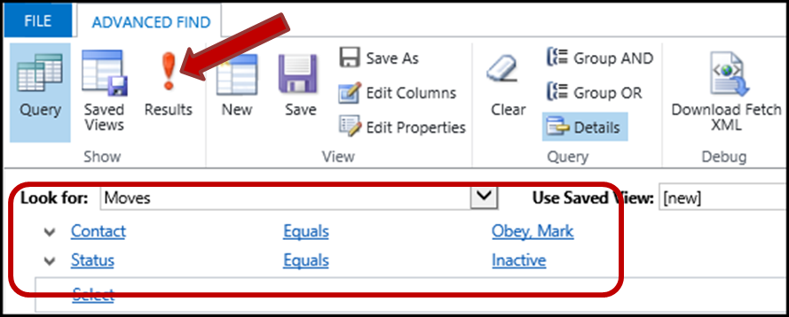

1. Select the **Results** button, to perform the search.
2. The found Move records will be displayed.
3. Continue to section Activate the Move.

## Activate the Move

1. The found Move record(s) will be displayed.
2. Select the desired Move record.
3. The **Move: Information** page will display.
4. Select the **Activate** button near the top left of the Move page. 
5. The Move **Status** is now “Active”.
6. The Move **Status Reason** is now “Pending”.
7. If there are Service Activities to be reactivated, perform the steps in section Reopen a Service Activity.

## Reopen a Service Activity

1. The Move should still be open, on the **Move: Information** page.
2. Scroll down to the **Service Activity** panel.
3. Open the Service Activity to be reactivated.
4. The **Service Activity** window will open and display.
5. Select the **Run Workflow** button, near the upper right of the window.

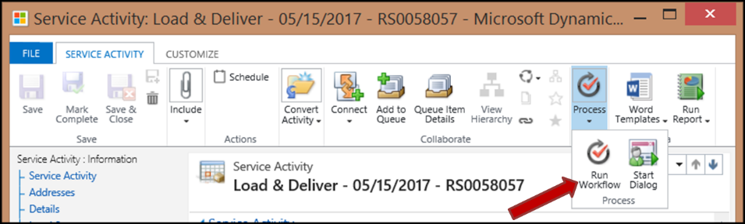

1. The **Look Up Record** light box will open and display.
   1. Select the process “Service Activity – Change Status to Pending” option.
   2. Select the **Add** button.

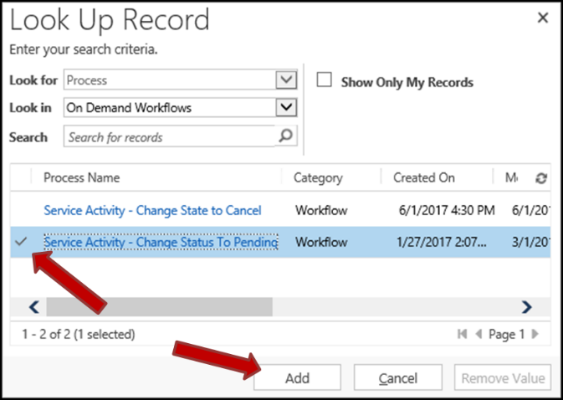

1. The **Confirm Application of Workflow** message light box will open and display.
   1. Asking “Are you sure that you want to continue?”
   2. Select the **OK** button.
2. You are returned to the **Service Activity** window.
   1. Select the **F5** button, if the **Service Activity** window doesn’t refresh.
3. The Service Activity **State** is now “Open”.
4. The Service Activity **Status** is now “Pending”.
5. Repeat the steps in this section for each Service Activity to be reopened, as needed.